Winter eye care – How can I protect my eyes during winter?

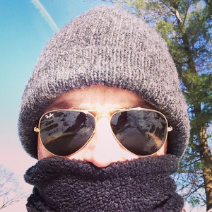
Photo credit: adwriter from Flickr
Got dry eyes?
Winter is coming. While that phrase’s meaning is not as dire as it is on HBO’s Game of Thrones, it does mean that eye protection is needed. Winter eye protection is often overlooked and the lack could cause some not-so-fun and even dire eye health issues. One of the main ones optometrists see is dry eyes. With cold weather comes increased use of heating systems both in our houses and cars. While the warm air certainly feels great, the heat and decreased humidity dry your skin and eyes. This is particularly true for contact lens wearers. An easy way to stay comfortable is to keep artificial tears handy and to point vents away from your face. Also, a humidifier can come in very handy for both your eyes and other sensitive tissues like the inside of your nose.

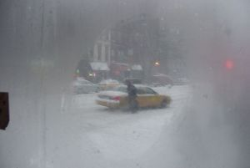
Photo credit: LaRimdaME from Flickr

Playing in the snow?
Winter also means ski season. We often warn patients about the dangers of ultraviolet light while playing in the snow. Ultraviolet light is even more powerful when reflected off of snow and with increased altitude. Too much exposure to ultraviolet light can cause a condition called photokeratitis. Some people can just have blurry vision for a day, or suffer much worse. That’s why it is very important to use UV-protecting sun glasses when hitting the slopes.

Quick Tip
Did you know that there is a coating you can get on your glasses that eliminates fogging? So, if you find yourself going from hot to cold environments quickly for work or play, or eating a hot bowl of soup on a cold day, you may want to ask your doctor about this technology. As you can see with a few simple steps, your eyes can be healthier and better protected in winter. So get out there, stay protected and have a great time!

